**Question Answer – 01**

* **Feature – 01:**

1. Customer should pay Merchant & Utility bill through EasyPay
2. Each Merchant payment 1% service charge needed
3. Minimum 5tk deduct from customer as transaction fee
4. Over 5000tk transaction gives 10% cashback
5. Over 10,000tk transaction gives 20% cashback
6. Maximum amount to get as cashback is 3000tk
7. No cashback offers for utility bills payment

* **Feature – 02:**

1. Less than 100tk in account can apply for loan up to 20,000tk
2. No interest will apply as soon as repay the loan within 30 days
3. Daily 1.8% interest will be applied on the remaining amount once 30 days loan pay deadline over
4. Once a customer paid 50% of remaining amount can apply for another loan

**Question Answer – 04**

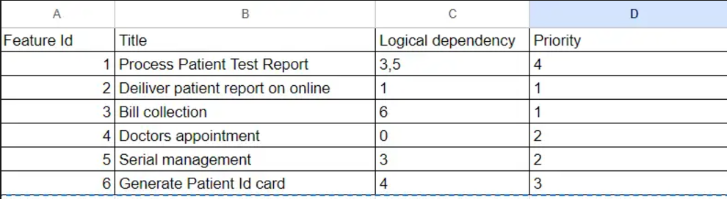

**Priority sequence:** 4 > 6 > 3 > 5 > 1 > 2

**Discussion:**

**Step 1-** If we see priority column **Feature Id 1 & 2** has the **highest priority**. But they both have logical dependencies. Also, if we see **Feature Id – 3,5 & 6** they also have logical dependencies. So, we need to check which Feature Id doesn’t have any logical dependency that is **Feature Id 4** (Doctors appointment)**.** So, it will be our first priority in the priority sequence. Now let’s update the priority sequency –

* **Priority sequence :** 4

**Step 2 –** Now let’s backtrack , let’s check which feature id has logical dependency or dependent on feature id 4. That is **Feature Id 6** (Generate Patient Id Card). Again, update the priority sequency –

* **Priority sequence :** 4 > 6

**Step 3 –** Again, let’s backtrack from feature id 6, let’s check which one has logical dependency or dependent on feature id 6. That is **Feature Id 3** (Bill Collection). Let’s update the priority sequency –

* **Priority sequence :** 4 > 6 > 3

**Step 4 –** Backtracking from feature id 3, We can see **feature id 1 & 5** both are dependent on feature id 3. But here comes a critical part, which one should come first? The answer should be – **Feature Id 5** (serial management). Because if we take **Feature id 1** (process patient test report) which has one more dependency which is 5. So, we cannot prioritize feature 1 before feature 5 because of dependency on feature id 5. Once we finish feature 5 , then only we can go for feature id 1. So, new priority sequence stands -

* **Priority sequence :** 4 > 6 > 3 > 5

**Step 5 –** Now backtracking from feature id 5, We can see **feature id 1** (process patient test report)is logically dependent on feature id 5. Since already feature id 3 is done so this time just one logical dependency left for feature id 1 which is 5. Let’s add this to priority sequence. New priority sequence stands -

* **Priority sequence :** 4 > 6 > 3 > 5 > 1

**Step 5 –** For final backtracking from feature id 1, **Feature id 2** (Doctor appointment)is logically dependent on feature id 1. Now Let’s add this to priority sequence. So, the final priority sequence stands like -

* **Priority sequence :** 4 > 6 > 3 > 5 > 1 > 2

**Question Answer – 05**

**For Feature – 01**: EasyPay Payment:

|  |  |  |  |
| --- | --- | --- | --- |
| **Sl** | **Checkpoint** | **Yes** | **No** |
| 1 | Does customer login with valid credentials? |  |  |
| 2 | Can a customer pay a merchant and utility bill with insufficient balance in their account? |  |  |
| 3 | Is the 1% merchant service charge deducted from the customer's account for every transaction they make? |  |  |
| 4 | Is the minimum transaction fee 5 Taka? |  |  |
| 5 | Should the customer receive 10% cashback on transactions over 5,000 Taka? |  |  |
| 6 | Is 10% cashback applied for less than 5,000 Taka transaction? |  |  |
| 7 | Should the customer receive 20% cashback on transactions over 10,000 Taka, with a maximum cashback limit of 3,000 Taka? |  |  |
| 8 | Is 20% cashback applied for less than 10,000 Taka transaction? |  |  |
| 9 | Is the cashback amount credited to the customer's account, and updated for every cashback received? |  |  |
| 10 | Is cashback applicable for utility bills? |  |  |

**For Feature – 02**: Loan:

|  |  |  |  |
| --- | --- | --- | --- |
| **Sl** | **Checkpoint** | **Yes** | **No** |
| 1 | Does customer apply for loan with zero balance in account? |  |  |
| 2 | Can a customer with less than 100 Taka in their account apply for a loan? |  |  |
| 3 | Can a customer with less than 100 Taka in their account apply for a loan up to 20,000 Taka? |  |  |
| 4 | If a customer repays the loan within 30 days, will interest be applied? |  |  |
| 5 | Is the interest rate 1.8% daily on the remaining amount if a customer fails to repay within 30 days? |  |  |
| 6 | Can a customer apply for another loan after repaying 50% or more of their existing loan? |  |  |